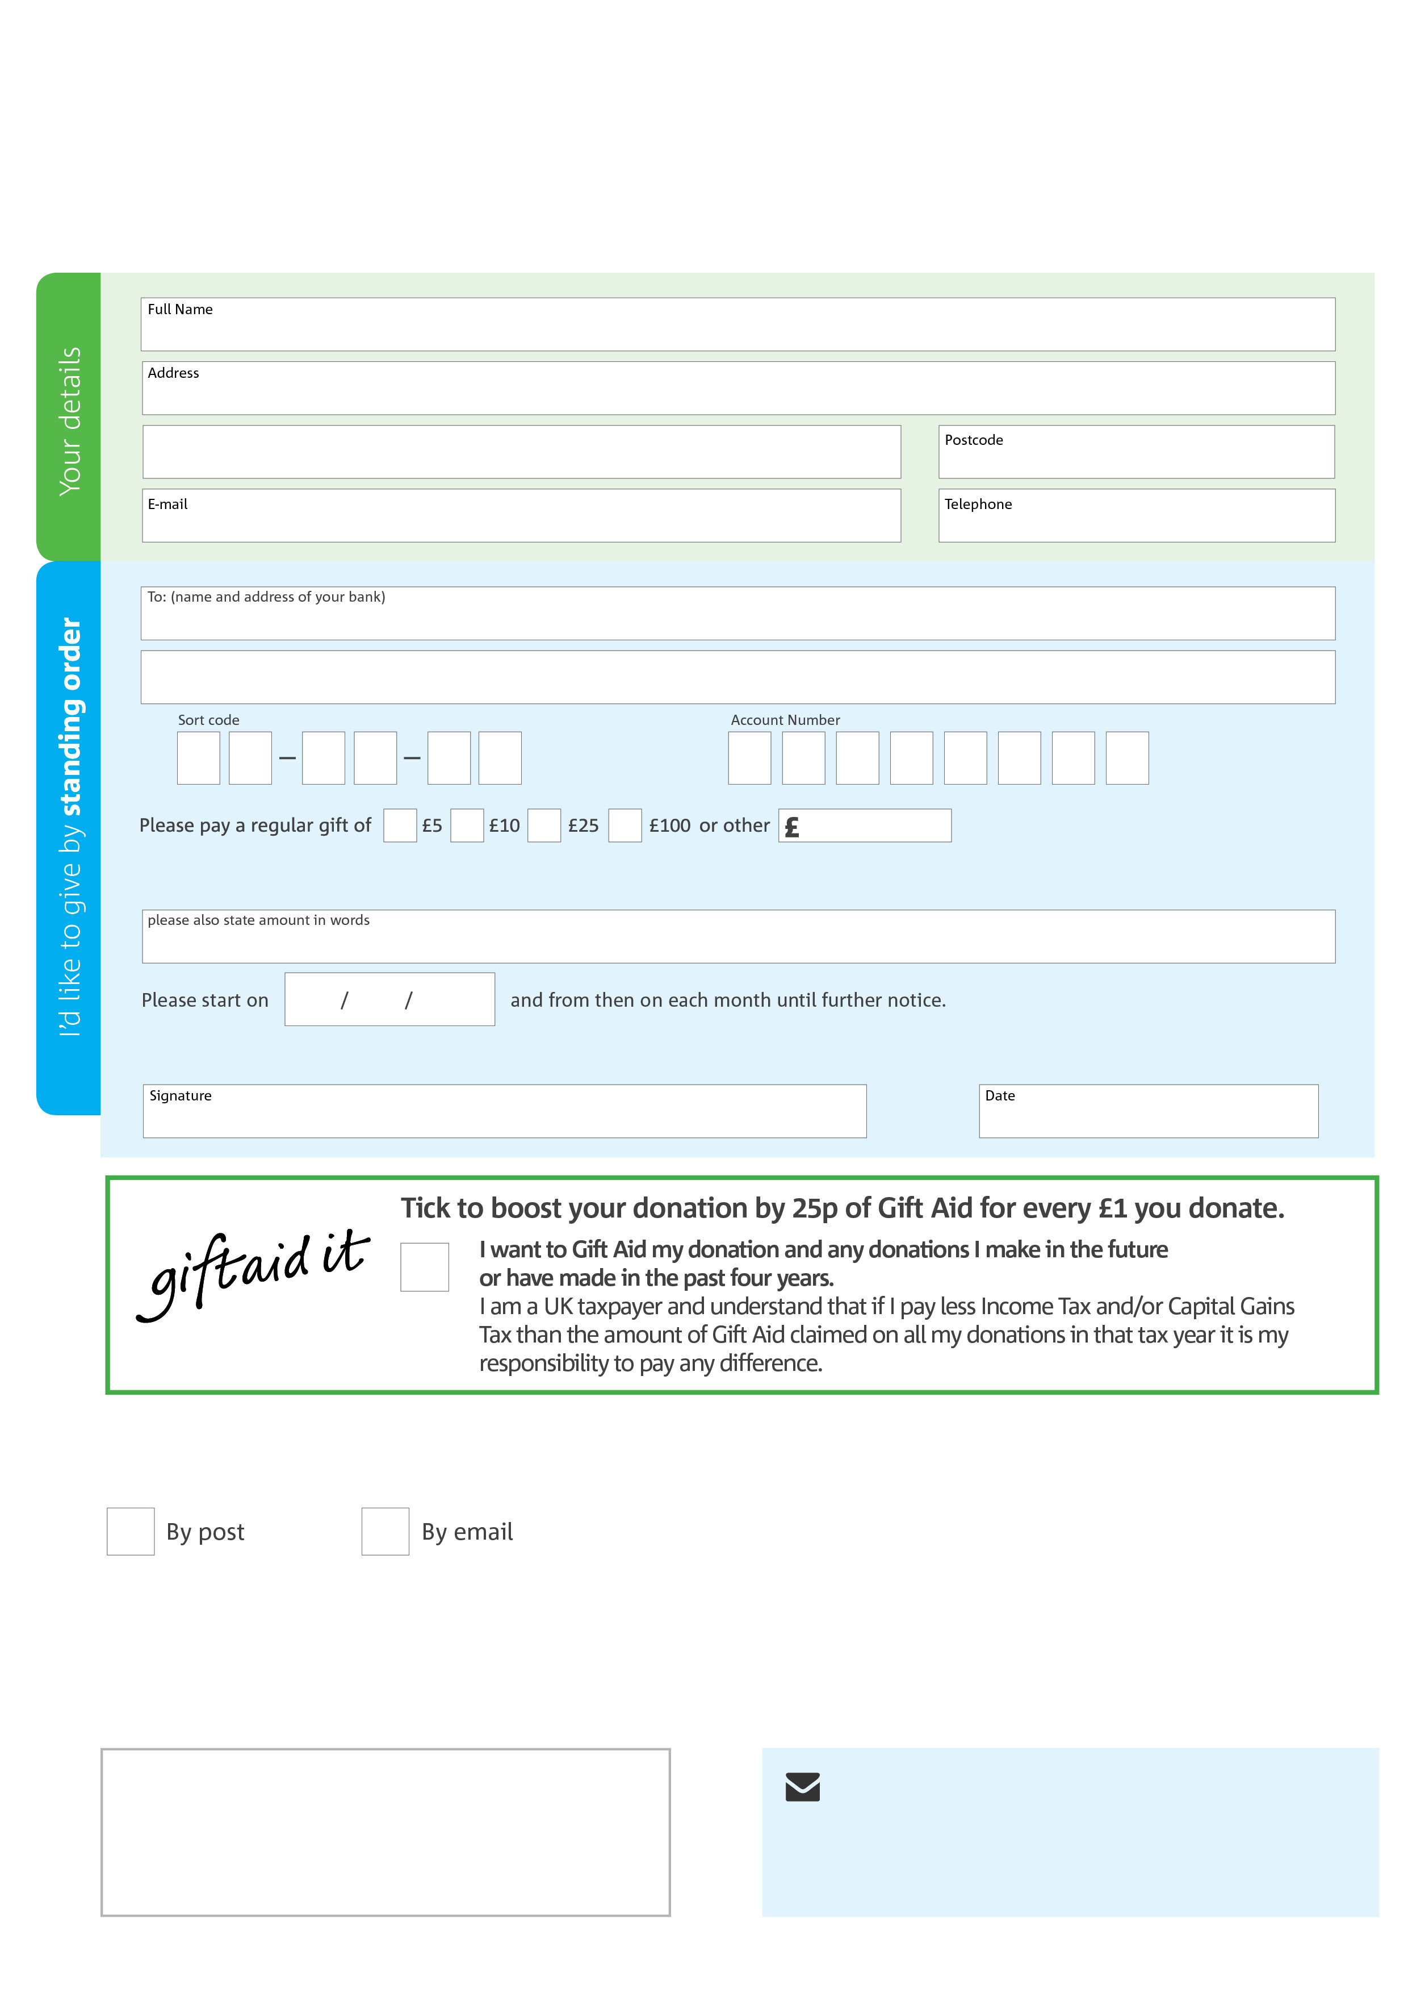­

**Please send your completed form to:**

Elaine Batten. Broxbourne Foodbank

18 Fairways  
New River Trading Estate   
Cheshunt, Herts,   
EN8 0NJ

Reg. Charity No: 1157199 Reg. in England & Wales

**Data protection**

Broxbourne Foodbank is committed to protecting your privacy and will process your personal data in accordance with current Data Protection legislation. Broxbourne Foodbank will never sell or pass your details onto anyone. A full data privacy statement for financial donors is available from the foodbank on request.

**We would love to keep in touch with you so we can update you on our work. You can change your preferences any time by contacting us on 07943 986261 or emailing us at infobroxbourne.foodbank@gmail.com**

**Please tick here if you would be happy to receive communications from us:**

**Broxbourne Foodbank’s bank details:**

Bank: **Lloyds Bank**

Account name: Broxbourne Foodbank

Sort code: 77-05-13

Account number: 15360568

This cancels any previous standing order instructions to Hertford & District Foodbank

To Hertford & District Foodbank each month,

