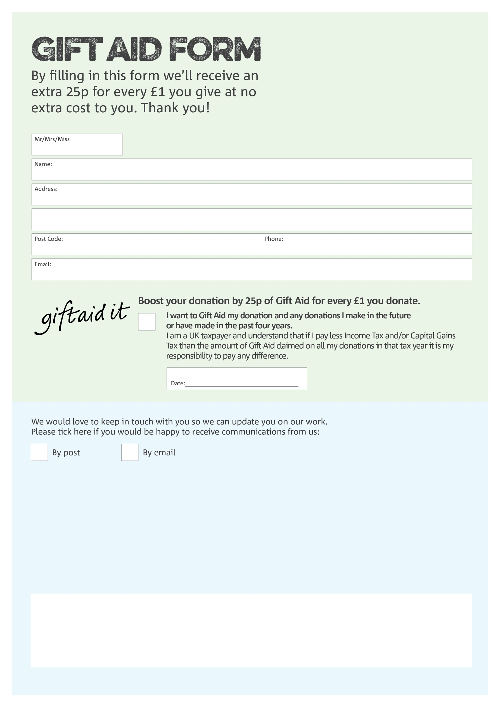 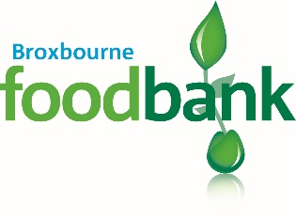

**Data Protection**

Broxbourne Foodbank is committed to protecting your privacy and will process your personal data in accordance with current Data Protection legislation. Broxbourne Foodbank will never sell or pass your details onto anyone. A full data privacy statement for financial donors is available from the foodbank on request.

You can change your preferences any time by contacting us on 07943 986261 or emailing us at

Infobroxbourne.foodbank@gmail.com

We would love to know why you have chosen to donate to Broxbourne Foodbank. If you would like to share your motivation let us know below:

Charity Number 1157028. Registered in England & Wales