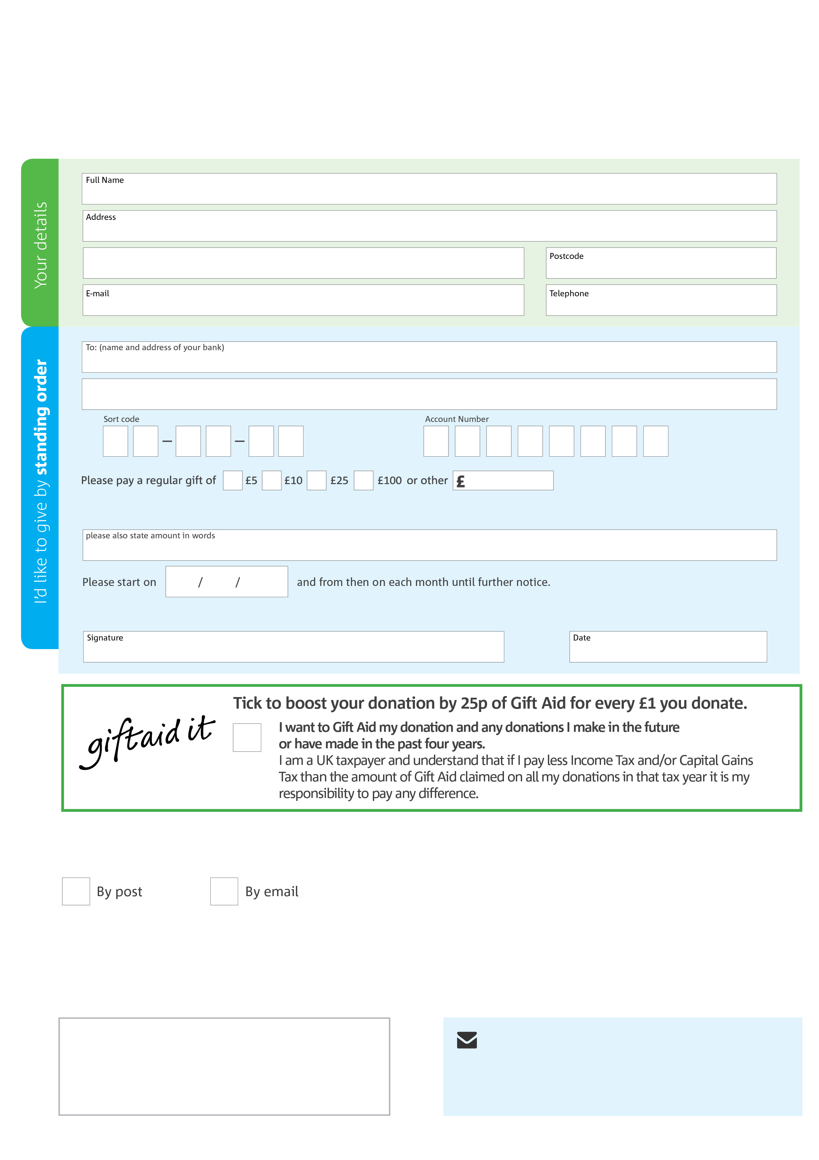
Please send a copy of your completed form to:
Elaine Batten. Broxbourne Foodbank
18 Fairways
New River Trading Estate
Cheshunt, Herts,
EN8 0NJ

Reg. Charity No: 1157199 Reg. in England & Wales
Data protection
Broxbourne Foodbank is committed to protecting your privacy and will process your personal data in accordance with current Data Protection legislation. Broxbourne Foodbank will never sell or pass your details onto anyone. A full data privacy statement for financial donors is available from the foodbank on request.
We would love to keep in touch with you so we can update you on our work. You can change your preferences any time by contacting us on 07943 986261 or emailing us at infobroxbourne.foodbank@gmail.com
Please tick here if you would be happy to receive communications from us:
Broxbourne Foodbank’s bank details:
Bank: Lloyds Bank
Account name: Broxbourne Foodbank
Sort code: 77-05-13
Account number: 15360568
This cancels any previous standing order instructions to Hertford & District Foodbank
To Hertford & District Foodbank each month,
